Name: __________________________________ Date: _____________ Period: _____

Laboratory Equipment

Match the name of the laboratory equipment with its picture by placing the letter which is under the picture of the equipment in the blank beside its name. In the blank to the right of the equipment’s name state briefly its function.

_____ 1. beaker ________________________________________________________

_____ 2. Bunsen burner __________________________________________________

_____ 3. medicine dropper ________________________________________________

_____ 4. funnel _________________________________________________________

_____ 5. graduated cylinder _______________________________________________

_____ 6. hand lens ______________________________________________________

_____ 7. pipette ________________________________________________________

_____ 8. metric ruler _____________________________________________________

_____ 9. safety goggles __________________________________________________

_____ 10. test tube ______________________________________________________

_____ 11. test tube rack __________________________________________________

_____ 12. thermometer __________________________________________________

_____ 13. triple-beam balance _____________________________________________

_____ 14. ring stand _____________________________________________________

_____ 15. wire gauze ____________________________________________________

_____ 16. Erlenmeyer flask _______________________________________________

_____ 17. stirring rod ____________________________________________________

_____ 18. test tube clamp ________________________________________________

_____ 19. hot hands _____________________________________________________

A B C D E

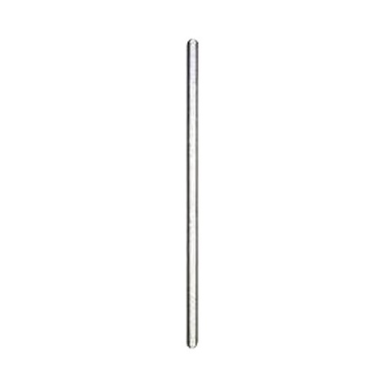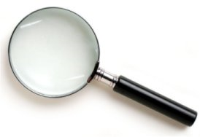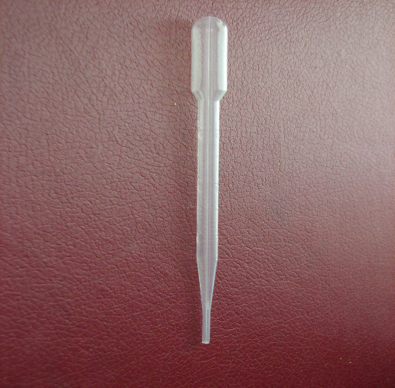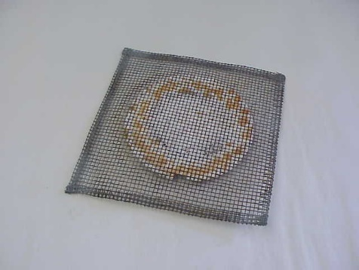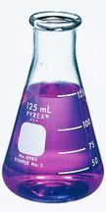

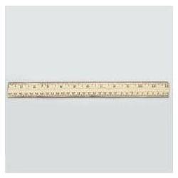

F G H I J

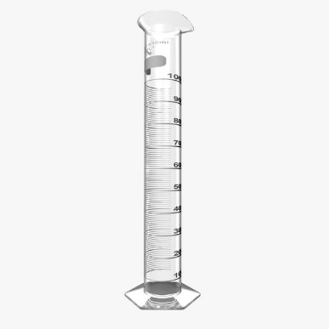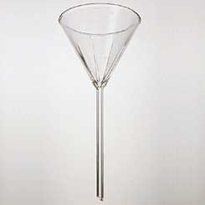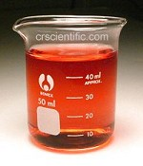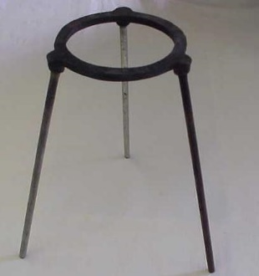

K L M N O

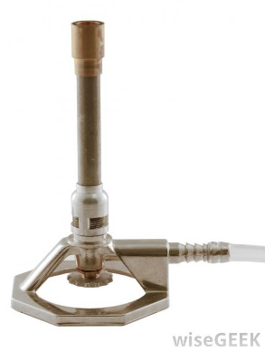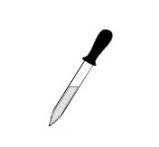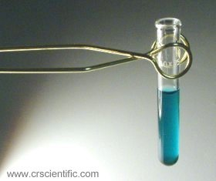

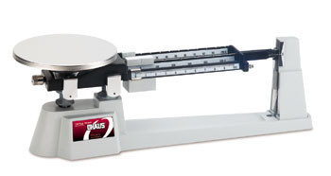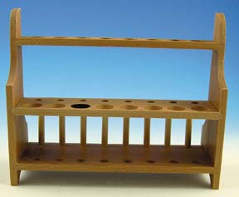

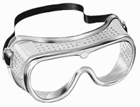

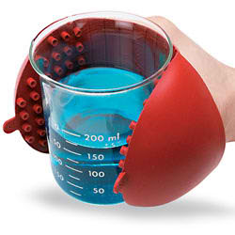P Q R S

